Template – Application for Graduation
The template named “Template – Application for Graduation” is applicable to Anthology Student.

Purpose and Outcome
This template provides a form sequence and supporting workflow for an Application for Graduation form to be submitted by a student. The sequence requires the following:
- A Student record must exist in the Anthology Student database.
- The student must have a Portal login to log into this authenticated sequence.
- The student must have a credit card to pay the fees associated with the application for graduation.
Forms Builder must support credit card payments using the PayPal or ACI payment or Touchnet gateways and must be configured for DocuSign. The template includes the steps required to collect a DocuSign signature from the student.
Upon completion of the sequence:
- The application for graduation form is added to the student record.
- The charge and payment are posted to the student’s ledger card.

Prerequisites
The template was built in Forms Builder using the applications listed below. The template is forward compatible with later versions of the listed applications.
Application | Compatibility Version
Forms Builder Designer and Renderer | Compatibility Matrix
Web Client for Anthology Student
Workflow Composer
Packages installed from Package Manager in Workflow Composer | Activities and Contracts (V2)  Contracts (V1)  Forms Builder Contracts  Note: Ensure that the Forms Builder Contracts package used in Workflow Composer is aligned with the version used in the Forms Builder. Additionally, confirm that both Activities and Contracts (V1) and Activities and Contracts (V2) packages in Workflow Composer match the versions used in the Student Web Client to avoid compatibility issues.  It depends on which product is being used, for example:  For CRM:  Activities And Contracts (CRM)  Forms Builder Contracts
Workflow Tracking Database | N/A
Staff STS | 3.3.x

Step 1: Download and Import the Template
- Download the template file (xml) to your environment (local drive or network location).
- Log into Forms Builder Designer.
- Click the Export/Import tile.
- Select the Import tab.
- Click Select exported file and navigate to the downloaded template file (xml).
- Click Import.
- Note: Import may fail if same files name is already available in environment or overwrite option.
- Export/Import

The following forms will be imported:

Application for Graduation

Application for Graduation Payment

Custom - Confirmation Standard No Auto Close

Default-Frame (used with DocuSign)

Step 2: In Form Designer…
- From the Forms slide out, select the Application for Graduation form.
This form uses the following school defined fields:
- Diploma Name
- Commencement Sessions
- Cap Size
- Gown Size
Ensure that these fields are available in your CampusNexus Student database and that appropriate values are configured for each field. Delete the original fields and drag the new fields that you created onto the form.
- Customize the form for your environment. Modify properties on current fields to make them required, etc., or add/remove fields on form.
Make sure you edit the text in the Labels and HTML controls as applicable for your institution.
- Fields and Components
- Save the form.
- Repeat steps 1-3 for the following forms:

Application for Graduation Payment

Custom - Confirmation Standard No Auto Close

Step 3: In Sequence Designer…
- Select the Application for Graduation sequence.
The sequence contains the following forms in this order:

Application for Graduation

Default-Frame

Application for Graduation Payment

Custom - Confirmation Standard No Auto Close
- Click Save As to create a copy of the sequence/workflow and customize the copy for your use. This way you can always refer to the original sequence/workflow you downloaded.
- Optional - Add a custom style (theme) associated with your campus.
- Themes
- Select your sequence in the Sequences pane.
- In the Properties Pane:
  - Ensure that the Authentication Product is Student.
- Select the End State Form named “Custom - Confirmation Standard No Auto Close”.
- Save the sequence.
- Open the associated sequence workflow.
Depending on your environment, either click Open Workflow in Sequence Designer or launch a local installation of Workflow Composer.
- Open the Workflows for a Sequence

Step 4: In Workflow Composer…
- Double-click the first form/state of the workflow named “Application for Graduation” and locate the and locate the activity named “Find Document”. This is a LookupReferenceItem activity.
In the Reference Item drop-down list, select a value that is appropriate for your environment.
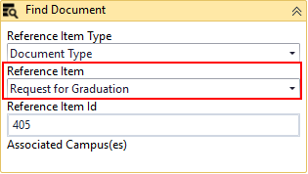
- LookuoReferenceItem activity

- Scroll down to the Assign Address Type activity and update the hard-coded value of “26” with a value that is appropriate for your CampusNexus Student database. This is the address type that you have configured in your database.
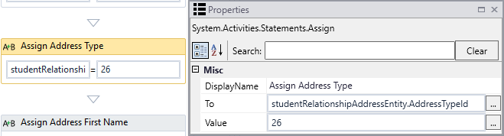

- Scroll further down to the Assign Amount activity and update the hard-coded value of “75.00d” with your institution’s graduation fee.
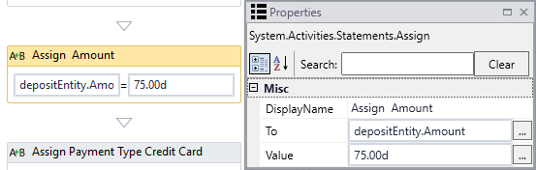

- Double-click the Submit transition towards the end of the workflow and locate the CreateCharge activity.
Select Charge Code and Transaction Type values applicable to your environment.
Update the hard-coded Amount value of “75.00d” as appropriate.
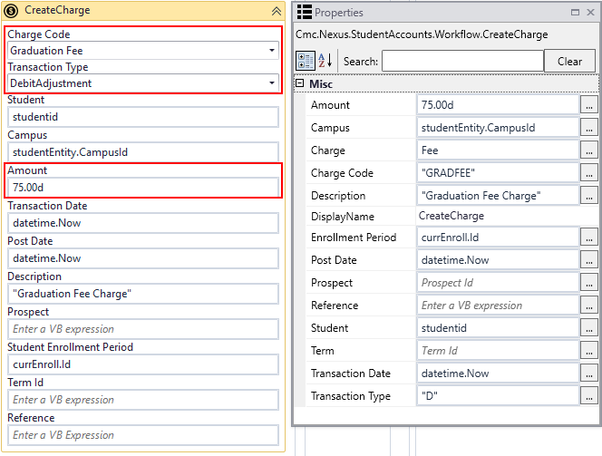
- CreateCharge activity
- Double-click the End state and locate the CreateDocument activity.
Select Document Type and Document Status values applicable to your environment.
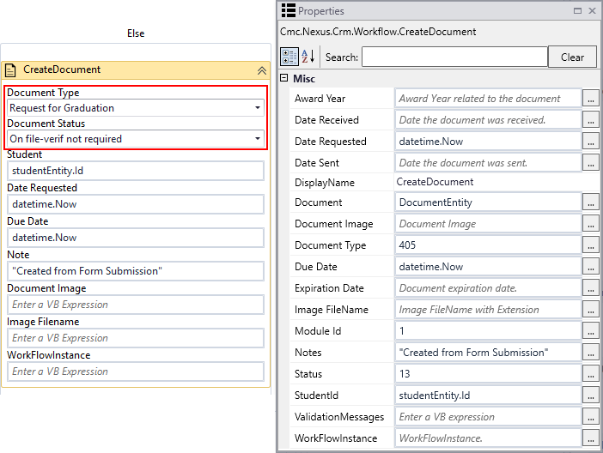
- CreateDocument activity
- Scroll down to the Assign Status activity and update the hard-coded value of “13” with a value that is appropriate for your CampusNexus Student database.
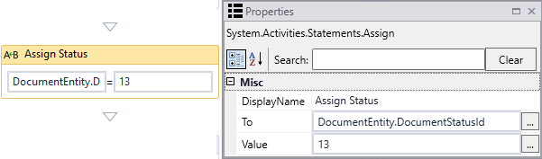

- Scroll further down and locate the CreateTask activity.
Select an appropriate Task Template.
In the Assign To field, specify a Staff Id value that is applicable to your environment.
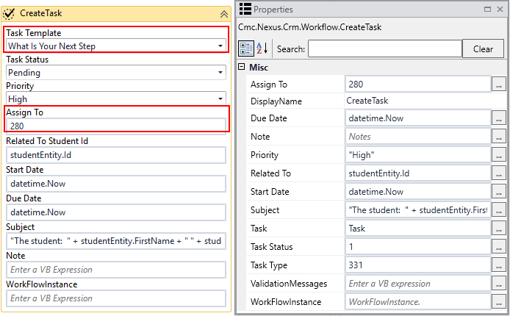
- CreateTask activity

Step 5: In Forms Renderer and Anthology Student…
Select your sequence and try it out!
- Sequence List
- Find your Application for Graduation sequence and copy the URL to the clipboard.
- Log in to Portal as a student and complete the form sequence.
- In CampusNexus Student,
  - Verify that application for graduation form is added to the student record.
  - Verify that the charge and payment are posted to the student’s ledger card.

Step 6: Lastly…
Once your updated sequence has been tested successfully, it is recommended that you disable the workflow for the original Template version.
- In Workflow Composer, in the Server section of the ribbon, click Open.
- Find the workflow named “Application for Graduation Sequence”.
- Clear the Enabled check box and click Save.

